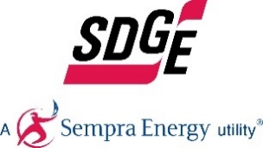

**Join our Internship Program**

**Guidelines and Eligibility**

* Must be available to work 75 hours over a four to six week timeframe, between November 12, 2018 through December 21, 2018.
* Intern and SDG&E employee will come up with an agreed upon work schedule.
* Compensation is $20.00 hour. Interns will receive $1500 (gross) for the 75 hours worked.

**Internships available in the following areas:**

* Human Resources
* Customer Services
* Legislative Affairs
* Asset Management
* Electric Operations

**Program Information:**

Come see first-hand what it’s like working at SDG&E. Participate in tours and/or ride-a-longs and complete work activities for the department.

Interns will receive a one-on-one resume review, interviewing tips and a “navigating the job market” information session with a Staffing Advisor.

Participants will be placed in their area of interest, as space permits.

**How to Apply:**

* [Click here](https://recruiting.adp.com/srccar/public/RTI.home?c=2168707&d=Confidential&r=5000413164006#/) and create a new user account.

**What’s it like to work at SDG&E®?**

Meet SDG&E employees, get an overview of the company, departments and positions.

Learn the **POWER** of a career in the energy industry and earn **$1,500**!